U18CO018

Shubham Shekhaliya

DWDM TUTORIAL-1

1. Generate the histograms for the frequency of values in the dataset uploaded to the classroom and study statistical characteristics like Mean, Mode, Median, Variance of any sample (Histograms can be generated in Excel/Python/Orange, etc).

2. Perform skewness analysis for the data and decide the suitable missing value replacement for the ratio scale and interval scale numerical data attributes.

3. Perform Missing value replacement by Mean, Mode, Median on the A attributes. Intentionally remove two values from that attribute and find the value of the X and Y for given data using mean value replacement (perform the operation on first 12 records).

4. Perform Noise identification, Outlier detection using histogram and try to remove the outliers and check the statistical characteristics again.

1)

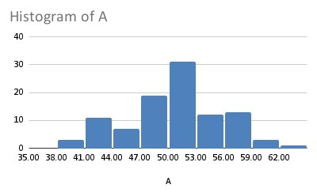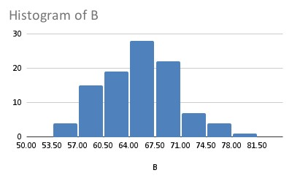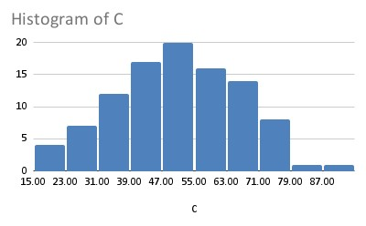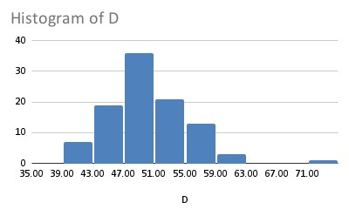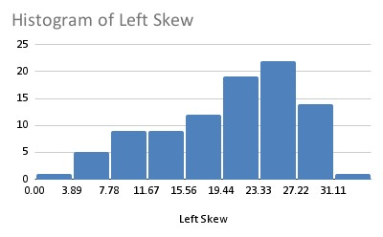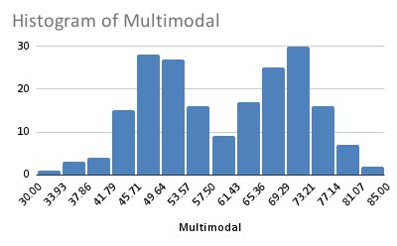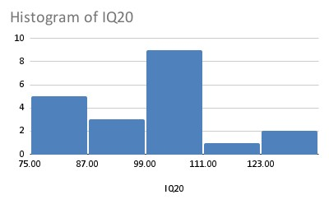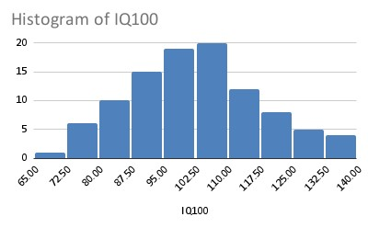

|  |  |  |  |  |  |  |  |  |  |  |
| --- | --- | --- | --- | --- | --- | --- | --- | --- | --- | --- |
| A | |  | B | |  |  | C |  | D | |
| Mean | 50.6321332 | Mean | 65.5445133 | Mean | 50.85133371 | Mean | 50.2115392 |
| Mode | #N/A | Mode | #N/A | Mode | #N/A | Mode | #N/A |
| Median | 50.6737108 | Median | 65.8987969 | Median | 51.65488244 | Median | 49.7266847 |
| Variance | 25.635211 | Variance | 25.8619987 | Variance | 235.387254 | Variance | 27.3395164 |
|  | |  | | |  | |  |  | | |
| Left Skew | |  | Multimodal | |  |  | IQ20 |  | IQ100 | |

|  |  |  |  |  |  |  |  |  |  |  |
| --- | --- | --- | --- | --- | --- | --- | --- | --- | --- | --- |
| Mean | 20.1076087 |  | Mean | 59.7345756 |  | Mean | 102.1324009 |  | Mean | 102.925179 |
| Mode | 23.1 | Mode | #N/A | Mode | #N/A | Mode | #N/A |
| Median | 21.5 | Median | 60.6020407 | Median | 105.6084021 | Median | 101.426575 |
| Variance | 49.6659854 | Variance | 132.553093 | Variance | 241.8311821 | Variance | 231.757566 |

2)

DWDM-TUT-1.py

import pandas as pd import math from copy import deepcopy

from pyod.models.hbos import HBOS

print("Imports loaded")

fname = "Histograms.csv"

df = pd.read_csv(fname)

# skewness analysis print(f"Skewness\n{df.skew()}") print("")

# kurtosis analysis

print(f"Kurtosis\n{df.kurt()}")

cmd: python DWDM-TUT-1.py

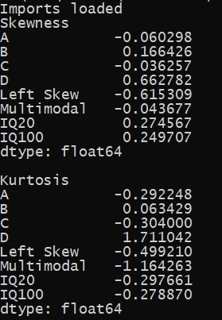

3)

4)